SIMATS ENGINEERING
SAVEETHA INSTITUTE OF MEDICAL AND TECHNICAL SCIENCES
CHENNAI-602105
Department of Computer Science and Engineering
ASSESSMENT TOOL 1 – SAVEETHA COMPILER ASSESSMENT (LEVEL 1 & VIVA VOCE)
Course Code: | CSA09 | Course Title: | Programming in Java
CO Assessed: | CO1 – Manipulation (BL4) | Assessment: | AT1 – Saveetha Compiler (Level 1 & Viva)
Weightage: | 20% of CIA | Total Marks: | 100 (5 Questions × 20 Marks)
CO1 Statement: | CO1: Apply object-oriented programming principles such as classes, objects, encapsulation, data hiding, inheritance, and polymorphism to design and implement entity manipulations (BL3,BL4)
Student Name: | B.ANJALI | Reg. No.: | 192371062
Section / Batch: | SLOT A/2023 | Date: | 27/7/2026

Instructions to Students
Answer ALL 5 questions. Total: 100 Marks.
Questions 1–5: Write complete, syntactically correct Java programs on the Saveetha Compiler with proper indentation. Each question carries 20 Marks.
For program questions: test with at least two sample inputs; ensure output is displayed clearly. Each question carries 5 Marks.
No calculators or electronic devices permitted during the viva session.

Question Type | Description | Questions | Marks
Level 1 – Program Writing | Control Flow, classes and Object programs, Collection Framework on compiler | Q1 – Q4 | 50
GRAND TOTAL: |  |  | 100 Marks

SECTION A – LEVEL 1: PROGRAM WRITING QUESTIONS (Q1–Q4)

Q1. (Level 1 – Program Writing) [20 Marks]

START

Set m = 4
Set n = 8

FOR i = 5 to n
Display m × i = (m × i)
ENDFOR

STOP

Answer / Program with output:
MATRIX MULTIPLICATION::

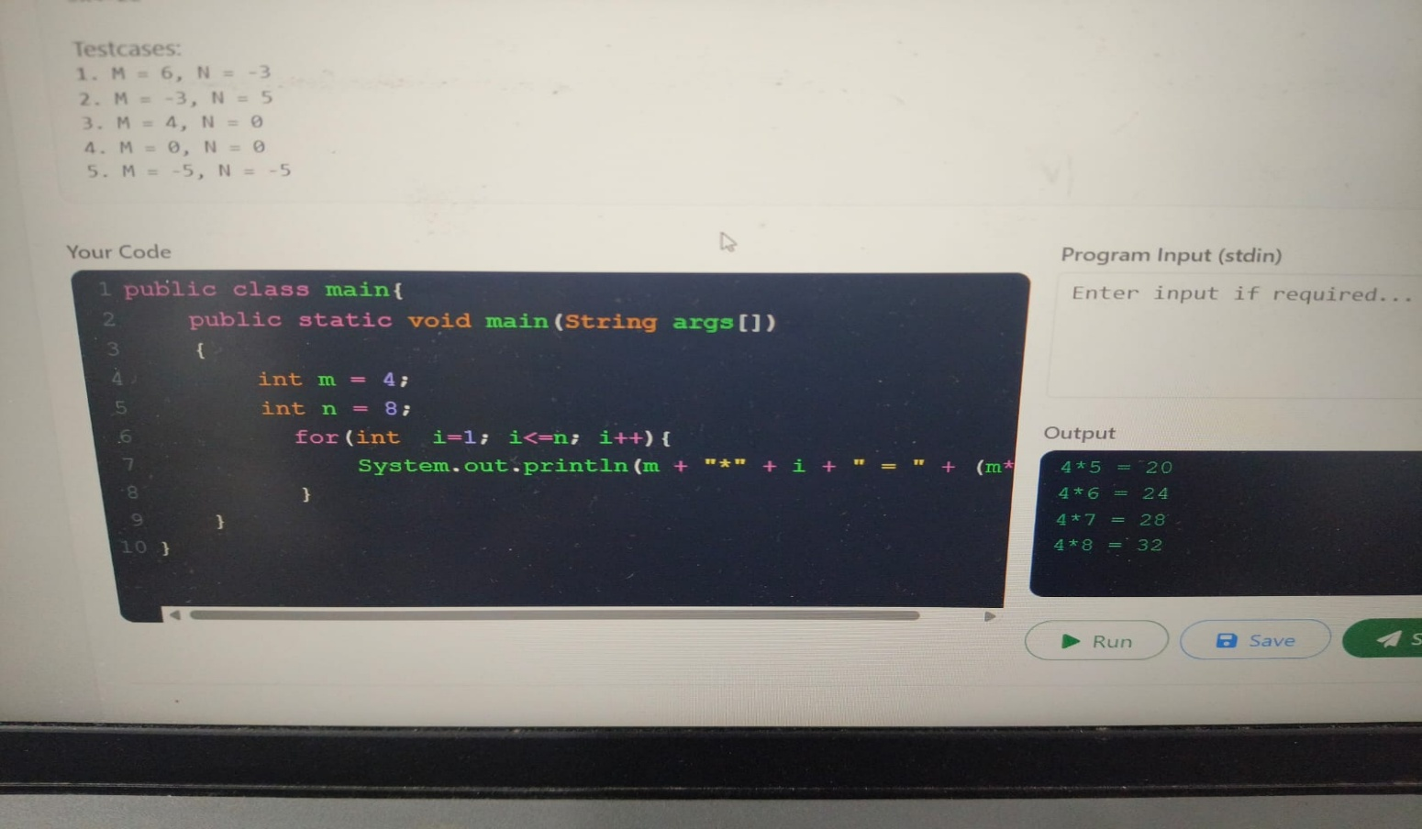

Q2. (Level 1 – Program Writing) [20 Marks]
HALF DIAMOND

START

Set rows = 5

FOR i = 1 to rows

IF i <= 3
count = i
ELSE
count = rows - i
ENDIF

FOR j = 1 to count
Print "1"
ENDFOR

Move to next line

ENDFOR

STOP

Answer / Program with output:

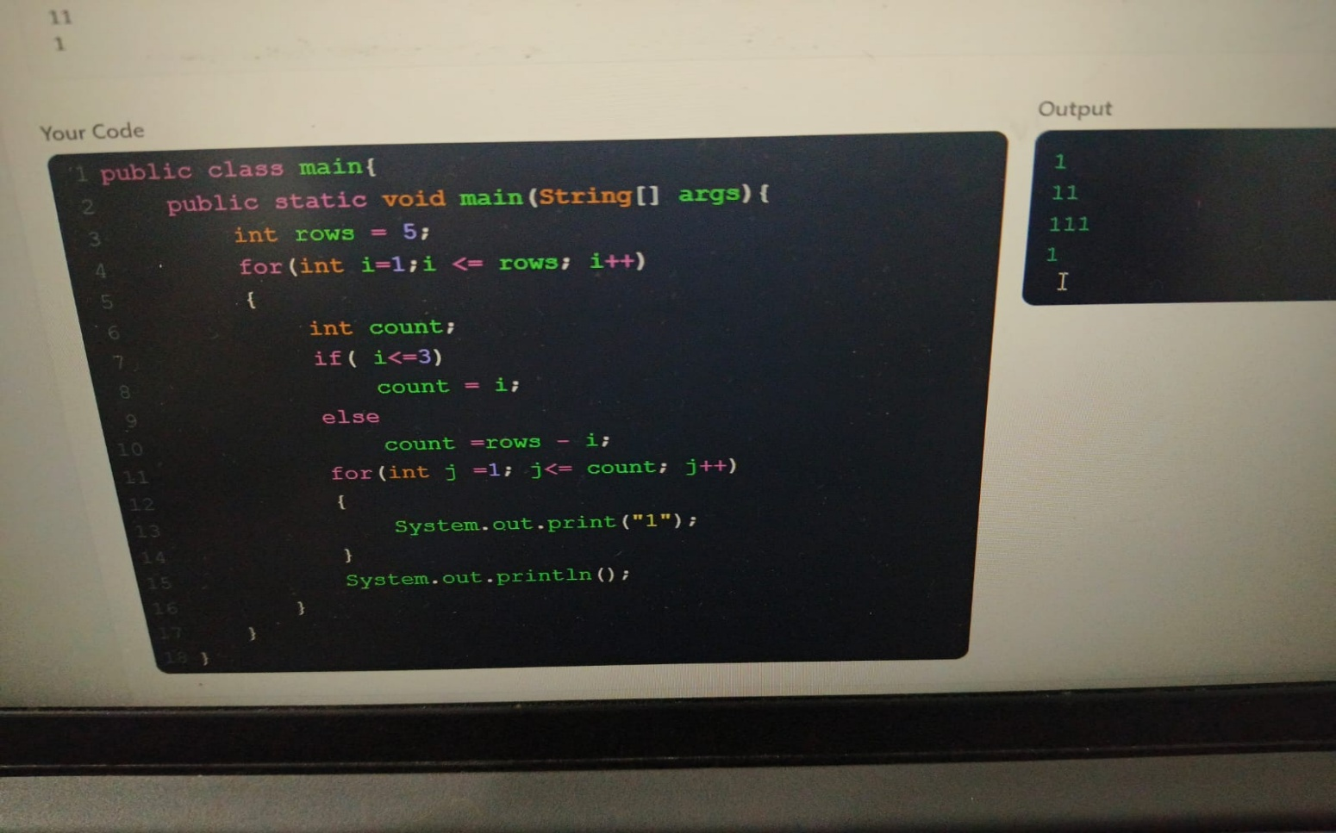

Q3. (Level 1 – Program Writing) [20 Marks]
COMPOSITE NUMBERS

START

Declare array

Display "Composite numbers are"

FOR each element in array
Set count = 0

FOR j = 1 to current element
IF current element is divisible by j
count = count + 1
ENDIF
ENDFOR

IF count > 2
Print current element
ENDIF
ENDFOR

STOP

Answer / Program with output:
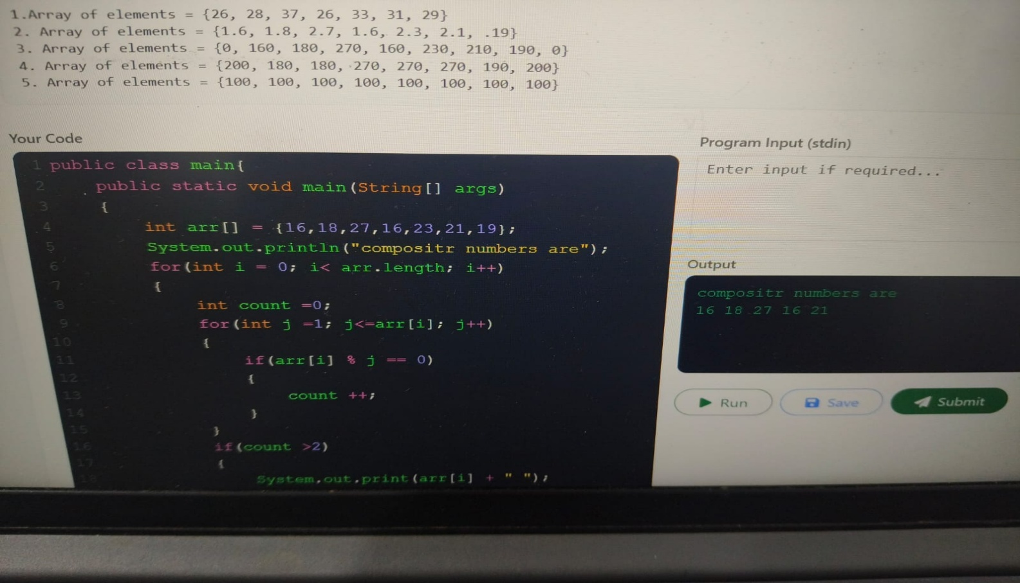

Q4. (Level 1 – Program Writing) [20 Marks]
VOWEL COUNT

START

Declare string str
Set count = 0

FOR each character in the string
IF character is A, E, I, O, U
OR character is a, e, i, o, u
count = count + 1
ENDIF
ENDFOR

Display "Number of vowels = ", count

STOP

Answer / Program with output:
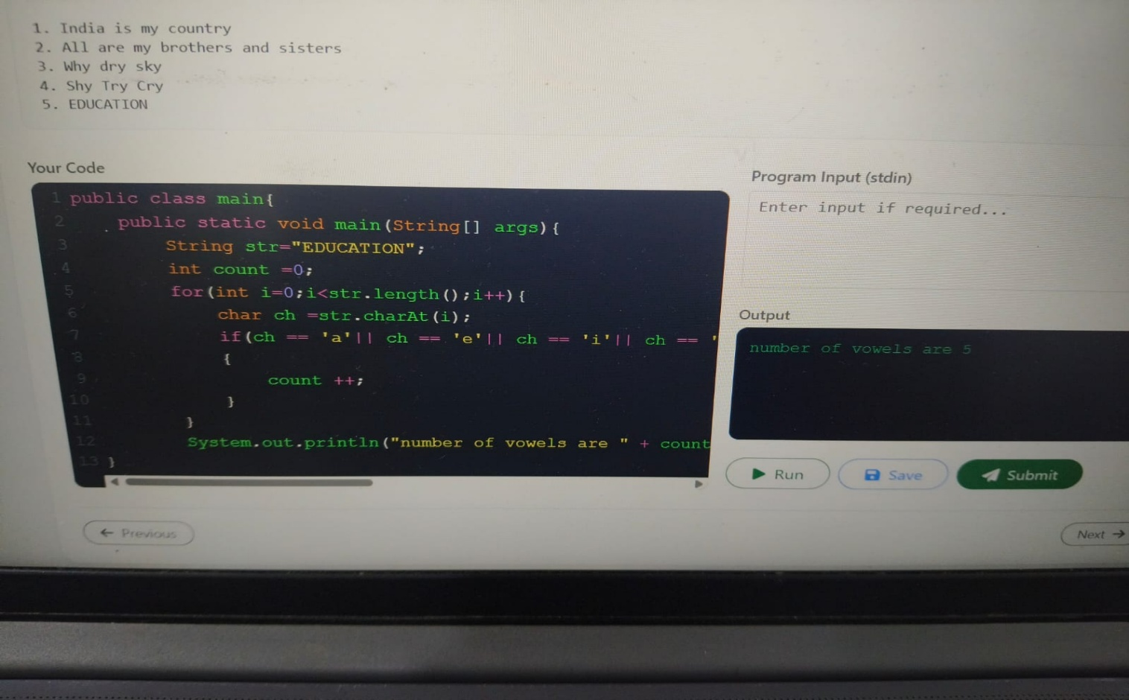

RUBRICS FOR EVALUATION

Criteria | Level 4 – Exemplary (5 Marks) | Level 3 – Proficient (3–4 Marks) | Level 2 – Developing (2 Marks) | Level 1 – Beginning (0–1 Mark)
Problem Analysis & Understanding
Logic / Algorithm Design
Python Syntax & String Operations
Output Correctness & Testing
Communication & Explanation (Viva)

Code of Conduct
I B.ANJALI (192371062) (Name / Reg No) certify that this submission is my original work and that I have adhered to the guidelines specified for this assessment. I understand that any violation of academic integrity rules will result in disciplinary action.
Signature of the Student: _________________________

